Nicholas Starace
ID: 4556822
D = 22
Question 1: Implementing and Verifying Code Functions
- 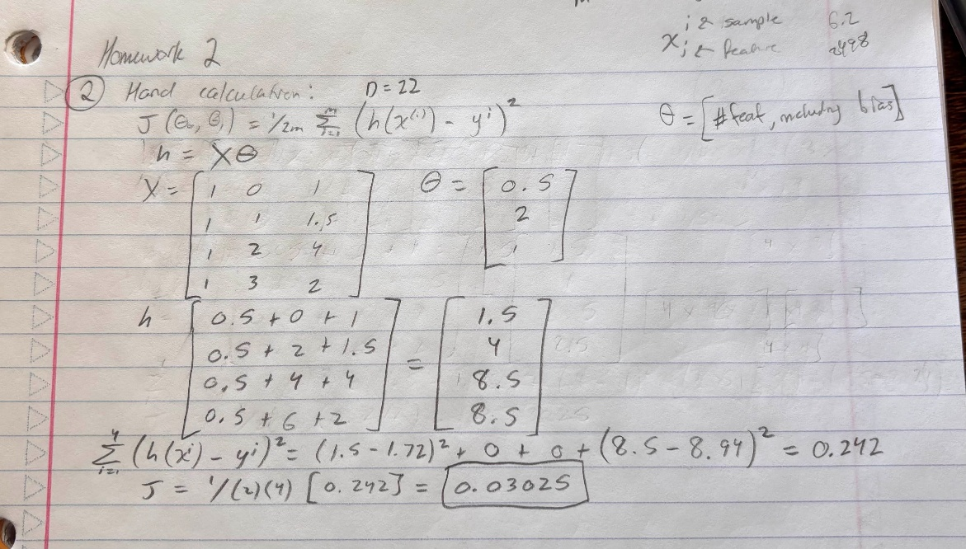
Cost Function = 0.0302; matches hand calculation.
Gradient Descent Theta = [0.6041; 2.0169; 1.0091]
Normal Equation Theta = [0.7372; 2.1384; 0.8683]
While the two theta estimates are similar, the estimates differ because the gradient descent is an iterative algorithm that gets close to but never actually reaches the ideal theta found by the normal equation. To make both approaches converge to the same solution, the number of iterations performed during gradient descent can be increased greatly and bring theta closer to the normal equation estimate.

Question 2: Applying Linear Regression to Real-World Data
- Dataset Name: Electricity Consumption Based on Weather Data
URL: https://www.kaggle.com/datasets/sudhirsingh27/electricity-consumption-based-on-weather-data
This dataset provides average daily wind speed (feature 1), daily precipitation (feature 2), daily maximum temperature (feature 3), and daily minimum temperature (feature 4).
The output variable represents total daily electricity consumption [kWh].
I chose this dataset for its relevance pertaining to unprecedented temperatures in today’s climate where high and low temperatures are becoming more extreme.
Number of Samples: 1418
Number of Features: 4
- Feature 1: Wind speed appears to be proportional and positively correlated with electricity consumption
Feature 2: Precipitation appears to be independent of electricity consumption since there is no obvious relationship with how the two variables move together. Energy consumption is widely spread across precipitation.
Feature 3: Maximum temperature appears to be inversely proportional and negatively correlated with electricity consumption.
Feature 4: Minimum temperature also appears to be inversely proportional and negatively correlated with electricity consumption.
Features 3 and 4 appear to have the strongest correlation with the output since the feature moves strongly in the opposite direction as electricity consumption.

- Feature 1 [mean std]: [2.6423 1.14]
Feature 2 [mean std]: [3.7343 10.8642]
Feature 3 [mean std]: [17.1327 10.1551]
Feature 4 [mean std]: [9.0858 9.0445]
X_train = 1276 x 5
Y_train = 1276 x 1
X_test = 142 x 5
Y_test = 142 x 1
- Learning Rate (alpha) was chosen as 0.1 because of the fast conversion towards ideal theta. Different rates of 0.01 and 1 were tested but were not as stable as the 0.1 rate chosen. When choosing a learning rate of 0.01, the algorithm took long to converge and potentially required additional iterations to reach the same result as a learning step of 0.1. A learning rate of 1 may have been viable but converged quickly and didn’t use the full allocated number of iterations.
Theta = [1560; 144.4]
The cost curve indicates convergence since it approaches zero and stabilizes by remaining approximately constant from iteration 50 to the end.

- Gradient Descent Theta = [1563; -18.1; -26.7; -18.6; -15.5]
Normal Equation Theta = [1563; -18.1; -26.7; -18.6; -15.5]
Both theta estimates are very close to one another. After increasing the step size from 0.01 to 0.1, gradient descent converged faster and closer to the normal equation estimate.
The normal equation executed faster with a duration of 0.0011 seconds while gradient descent took 0.0055 seconds to iterate.

- Univariate Cost: 16,3070
Multivariate Grad Descent: 14,3710
Multivariate Norm Eq: 14,3710
Multivariate regression using the normal equation performed the best on the test set since it had the lowest error and executed the fastest.
Adding additional features improved the performance and lowered the cost since it can explain additional variability in the output. By adding more features, the hypothesis is less subject to noise since it can explain variation in more directions equal to the number of features.

- Slow Convergence: alpha = 0.01
With this small alpha, the algorithm takes nearly all iterations to converge.
Smooth Convergence: alpha = 0.86
While the alpha has been increased greatly compared to the previous alpha, the algorithm converges faster requiring approximately 150 iterations to converge.
Oscillating Convergence: alpha = 0.8678
I was unable to find an alpha that overshoots but eventually converges (oscillates). At this alpha, the algorithm overshoots the cost at convergence but then diverges in the opposite direction to infinite cost with more iterations.
Divergence: alpha = 0.87
The alpha is large enough that the algorithm converges quickly and then diverges to infinite cost.
Learning rates can be difficult to select due to the tight range between fast convergence and divergence. A small alpha will converge but result in long runtime since gradient descent takes small steps. A large alpha will converge alpha but will diverge if it is too large. The ideal alpha is extremely difficult to find and may cause oscillation.
Feature standardization enables gradient descent in taking larger step sizes since all features are on the same scale. Therefore, the maximum stable alpha increases. Without standardization, you must use a small alpha since large scale features can easily blow up.

